2.6.18 Administration Reports Analytics and Export
Figure 18: Functional view for administration reports analytics and export

2.6.19 Encryption Audit Logging and Session Timeout
Figure 19: Functional view for encryption audit logging and session timeout

2.6.20 AI Medication Suggestion and Safety Check
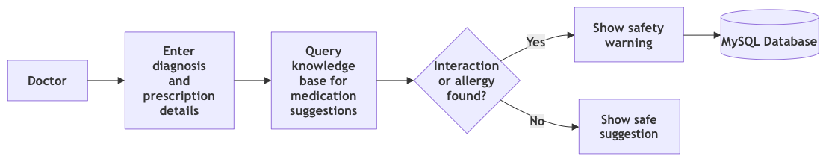
Figure 20: Functional view for ai medication suggestion and safety check

2.6.21 Nearest Partner Pharmacy Matching
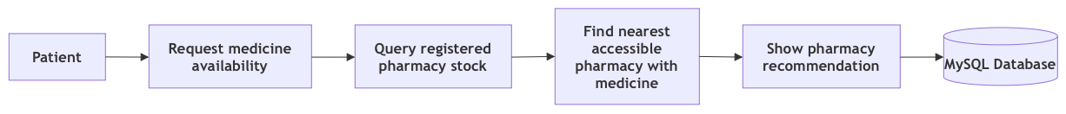
Figure 21: Functional view for nearest partner pharmacy matching

2.6.22 Medicine Stock Reservation
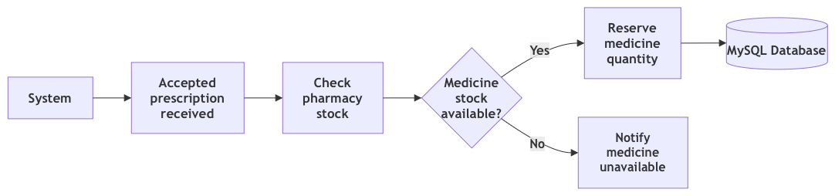
Figure 22: Functional view for medicine stock reservation

2.6.23 Shortage Prediction and TGA Check
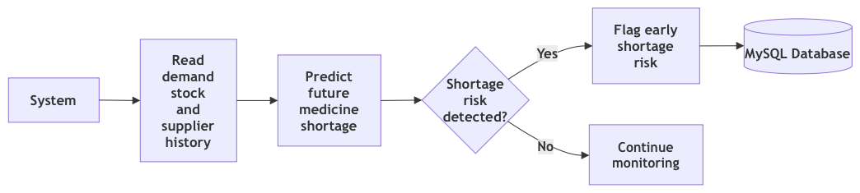
Figure 23: Functional view for shortage prediction and tga check

